English

A Whale of a Day in Botany Bay
  - Teaching Resources

A Whale of a Day Book Review for students
Welcome to the POD! Writing your own stories
Divine Devices

Science
Wild Weather- Fact sheet  Facts about Blue Whales  Mathematics  Whaley fun number bonds to 10  The Arts  Decorate a whale paper plate craft  Crazy Crab Craft using handprints  Colouring in sheets  S.T.E.M  Make your own book trailer using Stop-motion studio |  | 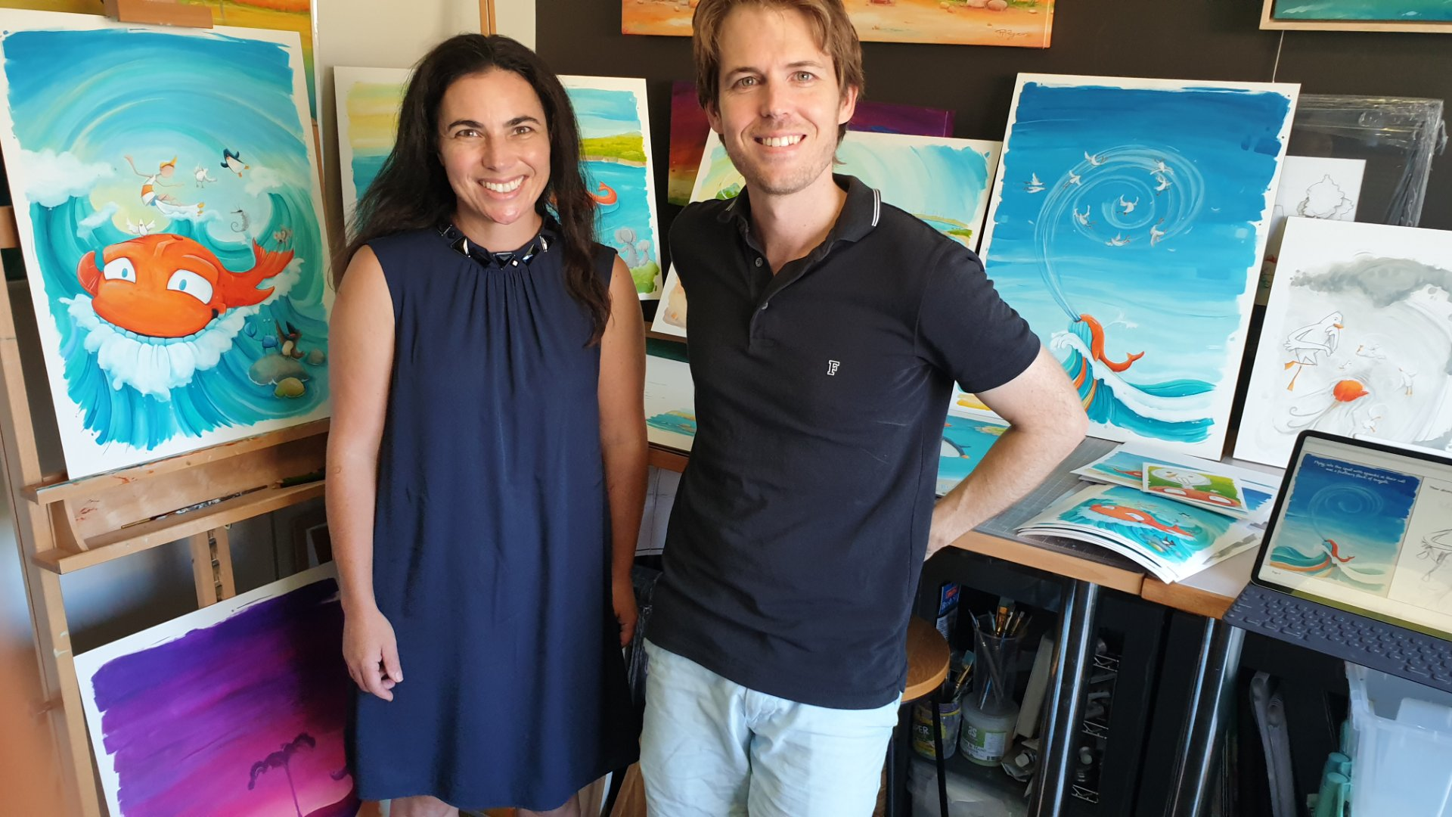  Author and Illustrator, Sian Turner and Peter Ryan

