What creates a sea breeze?  The energy from the sun makes air move by heating it.  Warm land heats the air above it, this air gets lighter and rises. Cool air from over the sea rushes in to take its place which makes wind.  Swirling storms  Different types of storms of wind and rain occur because of the way the earth spins. Winds can move in a spiral as they move from higher pressure areas to lower pressure. Have you heard of any of these?  Hurricanes  Typhoons  Cyclones  Tornadoes  Water spouts  Dust Devils  The fastest wind in the world is found inside a tornado.  A storm surge happens when winds make seawater surge up and flood the land.  Have you heard of prevailing winds?  These have been used to help sailors cross from one side of the world to the other. Trade winds help boats sail from Europe to the Caribbean  Whilst westerlies help them sail home again!  A doldrum occurs when two winds are fighting each other and sometimes put you at a standstill! | There is a chinook in this book!  Did you know that a chinook is the term for a warm dry wind that occurs on the downward slope of a mountain as it loses its moisture?  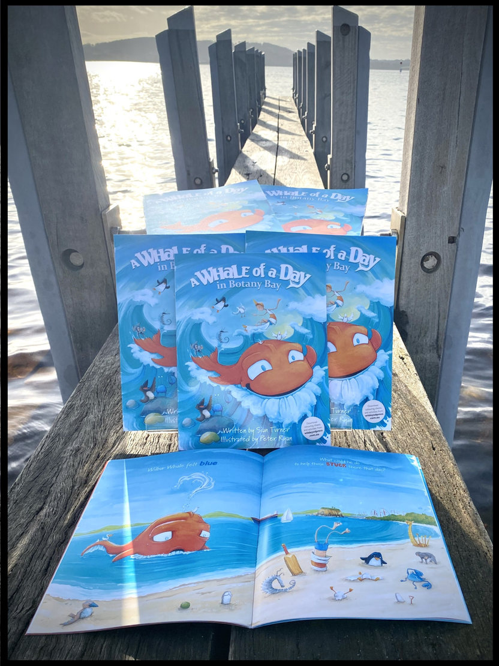  www.sianturnerbooks.com

