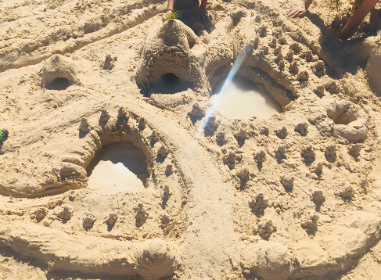
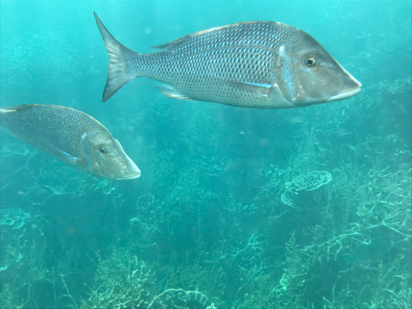
Divine Devices

A literary device is a technique used by a writer to make a sentence more interesting, more entertaining and easier to understand.

Can you spot any of the following literary devices used in
A Whale of a Day in Botany Bay?

- Alliteration- the repetition of consonant words
- Assonance- similar vowel sounds in closely placed words
- Rhyme- words, syllables or lines which have the same ending sound endings
- Personification- ascribing human-like qualities to non-human things
- Hyperbole- an obvious exaggeration
www.sianturnerbooks.com

